3/26/2022

3152 Hardik Togadiya

DCN

Assignment - 3

1. **Write a java program to perform the implementation of Checksum using TCP.**
2. import java.io.\***;**import java.net.\***;** import java.util.Scanner**;**class server_checksum  
   {  
    public static void main(String[] args) throws Exception  
    {  
     
    try  
    {  
     
     
     
    ServerSocket serversocket = new ServerSocket(6666)**;** System.out.println("server is listening on  
     
    localhost:6666");  
     
    Socket socket = serversocket.accept()**;** DataInputStream instream = new DataInputStream(socket.getInputStream())**;** DataOutputStream ostream = new DataOutputStream(socket.getOutputStream())**;** String rmsg = instream.readUTF()**;** System.out.println("\nReceive msg ="+rmsg)**;** int len = 4**;**// System.out.println(len); String result = "";  
     
    while(result.length()<len)  
    {  
    result="0"+result**;** }  
     
    for(int i=0**;**i<rmsg.length()**;**i+=len)  
    {  
    String temp = rmsg.substring(i**,**i+len)**;** result = binadd(result**,**temp)**;**// System.out.println("result = "+result);  
    }  
    result = ones(result)**;** System.out.println("final result = "+result)**;** int flag=0**;** for(int i=0**;**i<result.length()**;**i++)  
    {  
    if(result.charAt(i)!='0') System.out.println("Error")**;** else  
     
    }  
     
     
    flag=1**;** if(flag!=0)  
    System.out.println("Run Successfully.")**;** ostream.close()**;** instream.close()**;** socket.close()**;** serversocket.close()**;** }  
    catch(Exception e)  
    {  
    System.out.println(e)**;** }  
    }  
     
     
     
    public static String binadd(String a**,**String b)  
    {  
    String result = ""**;** String carry = "0"**;** for(int i=a.length()-1**;**i>=0**;**i--)  
    {  
     
    if(a.charAt(i)==b.charAt(i))  
    {  
    if(a.charAt(i)=='1')  
    {  
    if(carry == "0")  
    {  
     
     
     
    }  
    else  
    {  
     
    result = "0"+result**;** carry="1"**;** }  
    }  
    else  
    {  
     
    result = "1"+result**;** carry="1"**;** if(carry=="1")  
    {  
     
     
     
    }  
    else  
    {  
     
     
    }  
    }  
     
    result = "1"+result**;** carry="0"**;** result = "0"+result**;** carry="0"**;** }  
    else  
    {  
     
     
     
     
    if(carry=="1")  
    {  
     
     
     
    }  
    else  
    {  
     
     
    }  
    }  
    }  
     
    result = "0" + result**;** carry="1"**;** result = "1"+ result**;** carry="0"**;** if(carry == "1")  
    {  
    while(carry.length()<a.length()) carry="0"+carry**;**// System.out.print("carry encounter = "); result = binadd(carry,result);  
    }  
    return result**;** }  
     
    public static String ones(String msg)  
    {  
    String ans = ""**;** for(int i=0**;**i<msg.length()**;**i++)  
    {  
    if(msg.charAt(i)=='0')  
    {  
     
     
    }  
    else  
    {  
     
    }  
    }  
     
    ans = ans+"1"**;** ans = ans+"0"**;** return ans**;** }  
   }  
   import java.io.\***;** import java.net.\***;** import java.util.Scanner**;**class server_checksum  
   {  
    public static void main(String[] args) throws Exception  
    {  
     
    try  
    {  
     
     
     
    ServerSocket serversocket = new ServerSocket(6666)**;** System.out.println("server is listening on  
     
    localhost:6666");  
     
    Socket socket = serversocket.accept()**;** DataInputStream instream = new DataInputStream(socket.getInputStream())**;** DataOutputStream ostream = new DataOutputStream(socket.getOutputStream())**;** String rmsg = instream.readUTF()**;** System.out.println("\nReceive msg ="+rmsg)**;** int len = 4**;**// System.out.println(len); String result = "";  
     
    while(result.length()<len)  
    {  
    result="0"+result**;** }  
     
    for(int i=0**;**i<rmsg.length()**;**i+=len)  
    {  
    String temp = rmsg.substring(i**,**i+len)**;** result = binadd(result**,**temp)**;**// System.out.println("result = "+result);  
    }  
    result = ones(result)**;** System.out.println("final result = "+result)**;** int flag=0**;** for(int i=0**;**i<result.length()**;**i++)  
    {  
    if(result.charAt(i)!='0') System.out.println("Error")**;** else  
     
    }  
     
     
    flag=1**;** if(flag!=0)  
    System.out.println("Run Successfully.")**;** ostream.close()**;** instream.close()**;** socket.close()**;** serversocket.close()**;** }  
    catch(Exception e)  
    {  
    System.out.println(e)**;** }  
    }  
     
     
     
    public static String binadd(String a**,**String b)  
    {  
    String result = ""**;** String carry = "0"**;** for(int i=a.length()-1**;**i>=0**;**i--)  
    {  
     
    if(a.charAt(i)==b.charAt(i))  
    {  
    if(a.charAt(i)=='1')  
    {  
    if(carry == "0")  
    {  
     
     
     
    }  
    else  
    {  
     
    result = "0"+result**;** carry="1"**;** }  
    }  
    else  
    {  
     
    result = "1"+result**;** carry="1"**;** if(carry=="1")  
    {  
     
     
     
    }  
    else  
    {  
     
     
    }  
    }  
     
    result = "1"+result**;** carry="0"**;** result = "0"+result**;** carry="0"**;** }  
    else  
    {  
     
     
     
     
    if(carry=="1")  
    {  
     
     
     
    }  
    else  
    {  
     
     
    }  
    }  
    }  
     
    result = "0" + result**;** carry="1"**;** result = "1"+ result**;** carry="0"**;** if(carry == "1")  
    {  
    while(carry.length()<a.length()) carry="0"+carry**;**// System.out.print("carry encounter = "); result = binadd(carry,result);  
    }  
    return result**;** }  
     
    public static String ones(String msg)  
    {  
    String ans = ""**;** for(int i=0**;**i<msg.length()**;**i++)  
    {  
    if(msg.charAt(i)=='0')  
    {  
     
     
    }  
    else  
    {  
     
    }  
    }  
     
    ans = ans+"1"**;** ans = ans+"0"**;** return ans**;** }  
   }

import java.io.\***;**import java.net.\***;**import java.util.Scanner**;**class client_checksum  
{  
 public static void main(String[] args) throws Exception  
 {  
 try  
 {  
 Socket socket = new Socket("localhost"**,**6666)**;** DataOutputStream ostream = new DataOutputStream(socket.getOutputStream())**;** DataInputStream instream = new DataInputStream(socket.getInputStream())**;** Scanner sc = new Scanner(System.in)**;** System.out.print("Enter msg:")**;** String msg = sc.nextLine()**;** System.out.print("Enter length:")**;**// int len = sc.nextInt();  
// ostream.writeInt(len); int len = 4;  
  
 String result = new String()**;** while(result.length()<len)  
 {  
 result="0"+result**;** }  
  
 while(msg.length()%len!=0)  
 {  
 msg="0"+msg**;** }  
  
 for(int i=0**;**i<msg.length()**;**i+=len)  
 {  
 String temp = msg.substring(i**,**i+len)**;** System.out.print(result+" + "+temp+" = ")**;** result=binadd(result**,**temp)**;** System.out.println(result)**;**// System.out.println("result = "+result);  
 }  
 System.out.println("result = "+result)**;** result = ones(result)**;** System.out.println("result complement = "+result)**;** System.out.println("\nAddition = msg = "+msg+" +  
 result = "+result);  
 String sendmsg = msg + result**;** ostream.writeUTF(sendmsg)**;** ostream.flush()**;** System.out.println("sendmsg = "+sendmsg)**;** instream.close()**;** ostream.close()**;** socket.close()**;** }  
 catch(Exception e)  
 {  
 System.out.println(e)**;** }  
 }  
  
  
  
 public static String binadd(String a**,**String b)  
 {  
 String result = ""**;** String carry = "0"**;** for(int i=a.length()-1**;**i>=0**;**i--)  
 {  
  
 if(a.charAt(i)==b.charAt(i))  
 {  
 if(a.charAt(i)=='1')  
 {  
 if(carry == "0")  
 {  
  
  
  
  
  
  
  
  
  
 }  
 else  
 {  
  
  
  
 }  
else  
 {  
  
  
 }  
  
 result = "0"+result**;** carry="1"**;** result = "1"+result**;** carry="1"**;** if(carry=="1")  
 {  
  
  
  
 }  
 else  
 {  
  
  
 }  
 }  
  
 result = "1"+result**;** carry="0"**;** result = "0"+result**;** carry="0"**;** }  
 else  
 {  
  
  
  
  
 if(carry=="1")  
 {  
  
  
  
 }  
 else  
 {  
  
  
 }  
 }  
 }  
  
 result = "0" + result**;** carry="1"**;** result = "1"+ result**;** carry="0"**;** if(carry == "1")  
 {  
 while(carry.length()<a.length()) carry="0"+carry**;**// System.out.print("carry encounter = "); result = binadd(carry,result);  
 }  
 return result**;** }  
  
 public static String ones(String msg)  
 {  
 String ans = ""**;** for(int i=0**;**i<msg.length()**;**i++)  
 {  
 if(msg.charAt(i)=='0')  
 {  
 ans = ans+"1"**;** }  
 else  
 {  
  
 }  
 }  
  
 ans = ans+"0"**;** return ans**;** }  
}

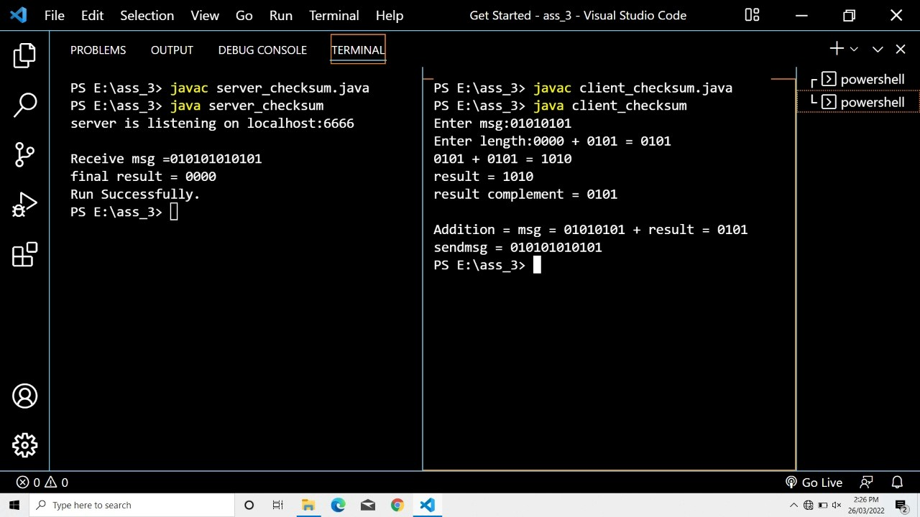

**2) Write a java program to perform the implementation of CRC Checksum using UDP.**

import java.net.\***;** import java.io.\***;**import java.util.Scanner**;**class receiver_crc  
{  
 public static void main(String args[]) throws Exception  
 {  
 try{  
 DatagramSocket ds1 = new DatagramSocket(6363)**;** System.out.println("server listening on localhost:6363")**;** byte[] buf = new byte[500]**;** DatagramPacket dp1 = new DatagramPacket(buf**,**500)**;** ds1.receive(dp1)**;** ds1.close()**;** String data = new String(dp1.getData()**,**0**,**dp1.getLength())**;** System.out.println("Received msg = "+ data)**;** String key = "11"**;** String rem = div(data**,**key)**;** System.out.println("rem = "+rem)**;** int cnt=0**;** for(int i=0**;**i<rem.length()**;**i++)  
 {  
 if(rem.charAt(i)=='0') cnt++**;** }  
 if(cnt!=0)  
 System.out.println("No error -> Successful.")**;**// DatagramSocket ds2 = new DatagramSocket();  
// Scanner s = new Scanner(System.in);  
  
// System.out.println("server:");  
// String msg1 = s.nextLine();  
// InetAddress ip = InetAddress.getByName("localhost");  
// DatagramPacket dp2 = new DatagramPacket(msg1.getBytes(),msg1.length(),ip,6565);  
// ds2.send(dp2);  
 }catch(Exception e)  
 {System.out.println(e)**;**}  
 }  
  
 public static String xor(String a**,** String b)  
 {  
 String result = ""**;** for(int i=1**;**i<a.length()**;**i++)  
 {  
 if(a.charAt(i) == b.charAt(i)) result = result + "0"**;** else  
 result = result + "1"**;** }  
 return result**;** }  
  
 public static String div(String data**,** String key)  
 {  
 int len = key.length()**;** for(int i=0**;**i<len-1**;**i++)  
 {  
 data = data + "0"**;** }  
  
 String zero = ""**;** for(int i=0**;**i<len**;**i++)  
  
 {  
 zero = zero + "0"**;** }  
  
 String temp = data.substring(0**,**len)**;** while(len<data.length())  
 {  
 if(temp.charAt(0)=='1')  
 temp = xor(temp**,**key) + data.charAt(len)**;** else  
 temp = xor(temp**,**zero) + data.charAt(len)**;** len++**;** }  
  
 if(temp.charAt(0)=='1') temp = xor(temp**,**key)**;** else  
 temp = xor(temp**,**zero)**;** return temp**;** }  
}

import java.net.\***;** import java.io.\***;**import java.util.Scanner**;**class sender_crc  
{  
 public static void main(String args[]) throws Exception  
  
 {  
 try{  
 DatagramSocket ds1 = new DatagramSocket()**;** Scanner sc = new Scanner(System.in)**;** System.out.print("Enter Data: ")**;** String data = sc.nextLine()**;** String key = "11"**;** String rem = div(data**,**key)**;** System.out.println("rem = "+rem)**;** String sendmsg = data + rem**;** System.out.println("send_msg = "+sendmsg)**;** InetAddress ip = InetAddress.getByName("localhost")**;** DatagramPacket dp1 = new DatagramPacket(sendmsg.getBytes()**,**sendmsg.length()**,**ip**,**6363)**;** ds1.send(dp1)**;** }catch(Exception e)  
 {System.out.println(e)**;**}  
 }  
  
 public static String xor(String a**,** String b)  
 {  
 String result = ""**;** for(int i=1**;**i<a.length()**;**i++)  
 {  
 if(a.charAt(i) == b.charAt(i)) result = result + "0"**;** else  
 result = result + "1"**;** }  
 return result**;** }  
  
 public static String div(String data**,** String key)  
 {  
 int len = key.length()**;** for(int i=0**;**i<len-1**;**i++)  
 {  
 data = data + "0"**;** }  
  
 String zero = ""**;** for(int i=0**;**i<len**;**i++)  
 {  
 zero = zero + "0"**;** }  
  
 String temp = data.substring(0**,**len)**;** while(len<data.length())  
 {  
 if(temp.charAt(0)=='1')  
 temp = xor(temp**,**key) + data.charAt(len)**;** else  
 temp = xor(temp**,**zero) + data.charAt(len)**;** len++**;** }  
  
 if(temp.charAt(0)=='1') temp = xor(temp**,**key)**;** else  
 temp = xor(temp**,**zero)**;** return temp**;** }  
  
}

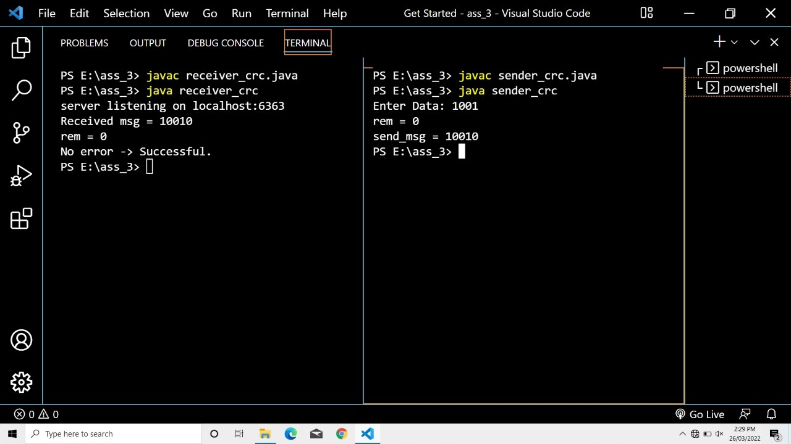

**3) Write a java program to perform the implementation of Hamming Code using UDP.**

import java.net.\***;** import java.io.\***;**import java.util.Scanner**;** import java.lang.Math**;** import java.util.Arrays**;**class receiver_hamming  
{  
 public static void main(String args[]) throws Exception  
 {  
 try{  
  
 DatagramSocket ds1 = new DatagramSocket(6363)**;** System.out.println("server listening on localhost:6363")**;** byte[] buf = new byte[500]**;** DatagramPacket dp1 = new DatagramPacket(buf**,**500)**;** ds1.receive(dp1)**;** ds1.close()**;** String data = new String(dp1.getData()**,**0**,**dp1.getLength())**;** System.out.println("Received msg = "+ data)**;**// int a = Integer.parseInt(data);  
// System.out.println(a); int totalbits = data.length(); int rbits = 3;  
 int databits = totalbits - rbits**;**// System.out.println(totalbits); int rhcode[] = new int[totalbits+1];  
  
//storing data into array for(int i=0;i<totalbits;i++)  
 {  
 rhcode[i] = data.charAt(i) - '0'**;** }  
 System.out.println("***** Received Code : *****")**;** for(int i=0**;**i<totalbits**;**i++)  
 {  
 System.out.print("rhcode["+i+"] : "+rhcode[i]+"\t")**;** }  
 System.out.println()**;**//create array to store errorbits int errorindex[] = new int[rbits];  
  
 for(int i=1**,**x=0**,**e=0**;** i<=totalbits**;** i++)  
  
 {  
 if(Math.pow(2**,**x)==i)  
 {  
 int counter = 0**;** for(int sindex=i**;** sindex<=totalbits**;** sindex=sindex+i+i)  
 {  
 for(int index=sindex**,**cinc=1**;** index<=totalbits && cinc<=i**;** index++**,**cinc++)  
 {  
  
  
 "+hcode[index]);  
  
//System.out.println("p["+index+"] :  
  
 if(rhcode[index] == 1)  
 {  
  
 counter++**;** }  
 }  
 }  
 if(counter % 2 != 0)  
 {  
 errorindex[e]=i**;** e++**;** }  
 x++**;** }  
 }  
  
//check if any error is there or not int sum=0;  
 System.out.print("\n errorIndex array values:")**;** for(int i=0**;**i<rbits**;**i++)  
 {  
 System.out.print(" "+ errorindex[i])**;** sum = sum + errorindex[i]**;** }  
  
//if sum < 0 then no error else error if(sum>0)  
 {  
 System.out.println("\n Error at index: "+ sum)**;**//correct error, flip the bit at error index (0 to 1) & (1 to 0) if(rhcode[sum]==0)  
 rhcode[sum]=1**;** else  
 rhcode[sum]=0**;** }  
else  
 {  
 System.out.println("\nNo error in hamming code.")**;** }  
  
 System.out.print("\n final received hamming code: ")**;** for(int i=totalbits**;** i>=1**;** i--)  
 {  
 System.out.print(rhcode[i])**;** }  
 System.out.println()**;**//extarct data from hamming code int rdata[] = new int[databits+1]; for(int i=1,x=1,d=0; i<=totalbits; i++)  
 {  
 if(Math.pow(2**,**x)==i)  
 {  
 x++**;** }  
  
 else  
 {  
 rdata[d] = rhcode[i]**;** d++**;** }  
 }  
  
 System.out.print("\n received Data: ")**;** for(int i = databits**;** i>=1**;** i--)  
 {  
 System.out.print(rdata[i])**;** }  
 System.out.println()**;** }catch(Exception e)  
 {System.out.println(e)**;**}  
 }  
  
}

import java.net.\***;** import java.io.\***;**import java.util.Scanner**;** import java.lang.Math**;**class sender_hamming  
{  
 public static void main(String args[]) throws Exception  
 {  
 try{  
 DatagramSocket ds1 = new DatagramSocket()**;** Scanner sc = new Scanner(System.in)**;** System.out.print("Enter Length of data:")**;** int databits = sc.nextInt()**;** int rbits = 0**;** System.out.println("\nCalculating rbits:")**;** while(Math.pow(2**,**rbits) < databits+rbits+1)  
 {  
  
  
 1");  
  
 System.out.println("2^" + rbits + " < " +databits+" + "+rbits+" +  
  
 rbits++**;** }  
  
  
 int totalbits = databits + rbits**;** System.out.println("\nData bits: "+databits)**;** System.out.println("Redundent Bits: "+rbits)**;** System.out.println("Total Bits: "+totalbits)**;**//create array and store the data int data[] = new int[databits+1];  
  
//data stored in reverse order System.out.println("\nEnter data into array:"); for(int i=databits; i>=1; i--)  
 {  
 data[i] = sc.nextInt()**;** }  
 System.out.println()**;**//printing array  
 System.out.println("\n *****data array:*****")**;** for(int i=1**;**i<=databits**;** i++)  
 {  
  
 System.out.print("\tdata["+i+"] = "+data[i])**;** }  
 System.out.println()**;**//create array & store hamming code int hcode[] = new int[totalbits+1];  
  
//set values in hamming code  
 for(int i=1**,** x=0**,** k=1**;** i<=totalbits**;** i++)  
 {  
 if(Math.pow(2**,** x) == i)  
 {  
 hcode[i] = 0**;** x++**;** }  
 else  
 {  
 hcode[i]=data[k]**;** k++**;** }  
 }  
//printing hcode array  
 System.out.println("\n *****hcode array:*****")**;** for(int i=1**;**i<=totalbits**;**i++)  
 {  
 System.out.print("\thcode["+i+"] = "+hcode[i])**;** }  
 System.out.println()**;**//calculating value of rbits for(int i=1,x=0; i<=totalbits;i++)  
 {  
 if(Math.pow(2**,**x)==i)  
  
 {  
 int counter = 0**;** System.out.println("\nrbits index : "+i)**;** for(int sindex=i**;** sindex<=totalbits**;** sindex=sindex+i+i)  
 {  
 for(int index=sindex**,**cinc=1**;** index<=totalbits && cinc<=i**;** index++**,**cinc++)  
 {  
 System.out.print("\tp["+index+"] : "+hcode[index])**;** if(hcode[index] == 1)  
 {  
 counter++**;** }  
 }  
 }  
 if(counter % 2 != 0)  
 {  
 hcode[i]=1**;** }  
 else  
 {  
 hcode[i]=0**;** }  
 x++**;** }  
 }  
  
//print final hamming code System.out.print("\n hamming code:\t"); String store = "";  
 for(int i=totalbits**;** i>=1**;** i--)  
 {  
  
 System.out.print(hcode[i])**;** store += Integer.toString(hcode[i])**;** }  
 System.out.println()**;** InetAddress ip = InetAddress.getByName("localhost")**;** DatagramPacket dp1 = new  
 DatagramPacket(store.getBytes()**,**store.length()**,**ip**,**6363)**;** ds1.send(dp1)**;** }catch(Exception e)  
 {System.out.println(e)**;**}  
 }  
  
}

